**Question Paper**

**Module 1**

**3 marks**

**7marks**

1. Write the equivalent HTML code to implement the following in a web page:

1) An image titled “flower.jpg” with proper attribute to set height, width and message text.

2) Unordered list with values tea, coffee and milk

1. Explain following html tags with proper example. 1. 2. < span> 3.< tr> 4.< form> 5.
2. Design a webpage that displays the following table.

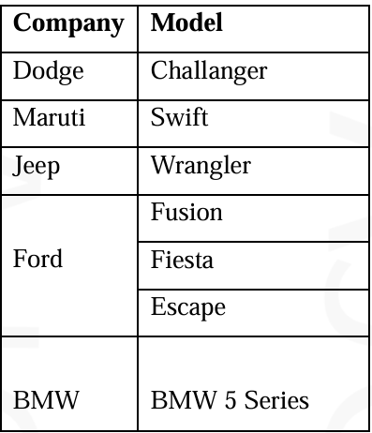

1. Write down the general format of an HTTP request and an HTTP response. What is the purpose of the following HTTP headers? Also, identify whether they are included with an HTTP header/response or both. i. host ii. last-modified

**Module 2**

**3 marks**

**7marks**

1. Write CSS code for the following:
   1. i) set the background color for the hover and active link states to "yellow".
   2. ii) Set the list style for ordered lists to "lower case alphabet".
   3. iii) Set "Boat.gif" as the background image of the page.
   4. iv) Set dotted border for the document.
2. Discuss various types of control statements in JavaScript.
3. How are event handlers registered in JavaScript? Write the code for an HTML document with embedded JavaScript scripts, which initially displays a paragraph with text “Welcome” and a button titled “Click”. When the button is clicked, the message “Hello from JavaScript” in bold should replace the paragraph text.
4. What are class selectors in CSS? Suppose that it is required to display the text content of p tags in two different styles depending on the context.
   1. Style 1 – text should be displayed in blue colour, right aligned, underlined, with font style of italics and spacing between the words of text set to 2 cm.
   2. Style 2 – text should be displayed with a background colour of yellow, blue colour border, and with a padding of 1.5 cm Write the equivalent CSS style rules.
5. Explain different levels of CSS Style Sheets with suitable example.
6. Write JavaScript program to find factorial of a number, use prompt dialog box to get the input from user.
7. Write CSS and the corresponding HTML code for the following:
   1. ii. Set the background color for the hover and active link states to "yellow".
   2. Set the list style for ordered lists to "lower case alphabet".
   3. Set "boat.jpg" as the background image of the page and set 3% margin for the page.
   4. iv. Set dotted border for the document.
8. Explain various types of control statements in JavaScript with example.
9. Explain CSS and its types. How can CSS be used to display a XML document? Illustrate with an example.
10. Explain the concept of Class selectors in CSS with examples.
11. Describe Java Script. Discuss various types of control statements in JavaScript.

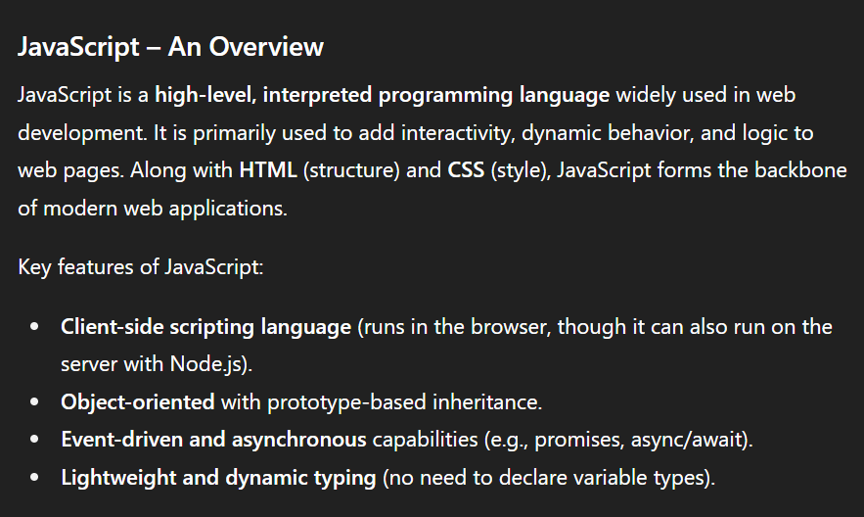

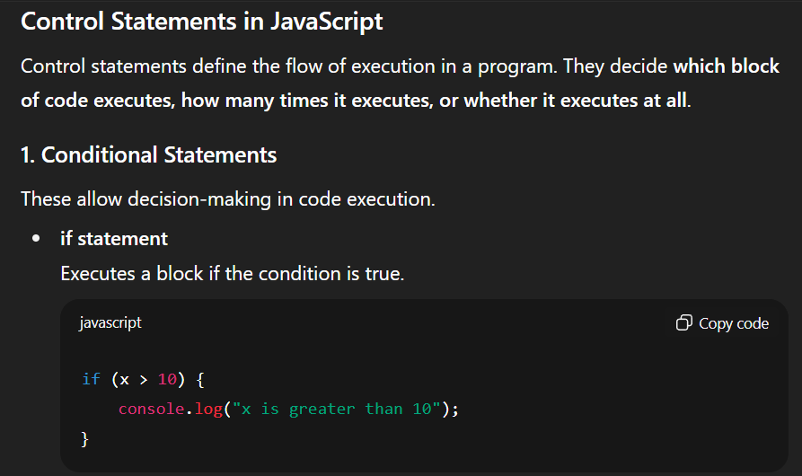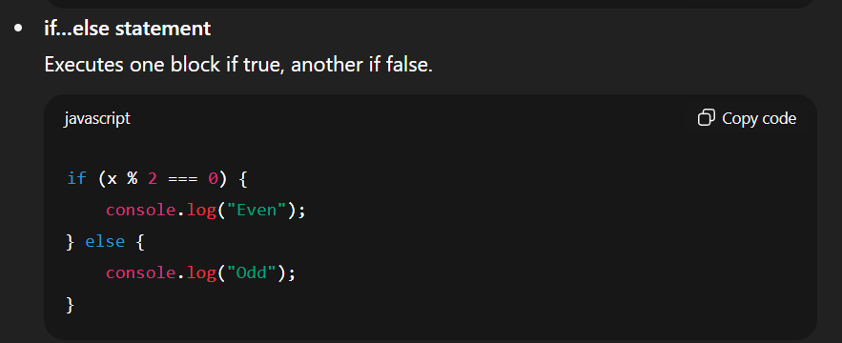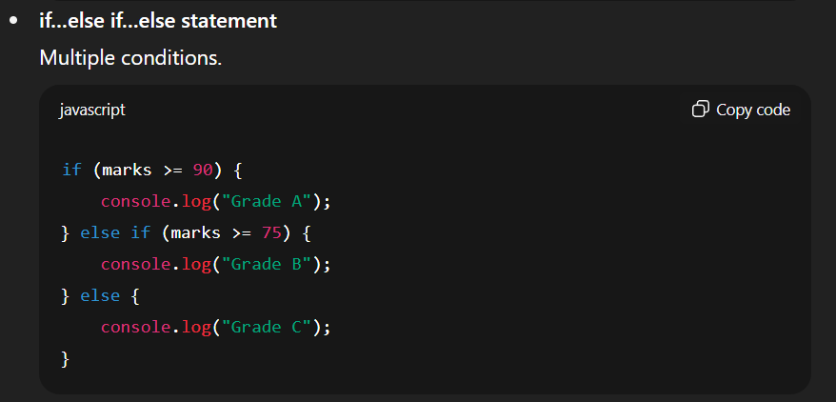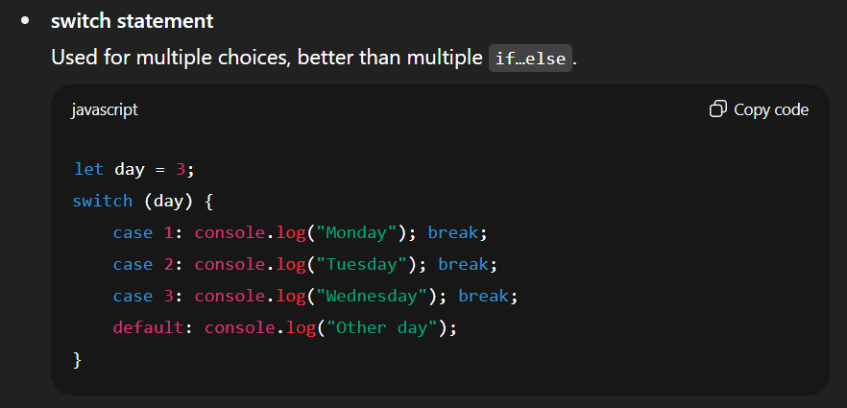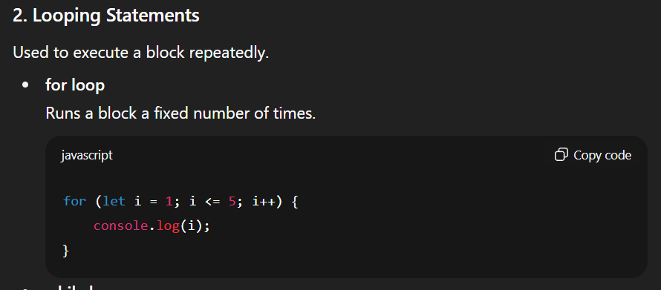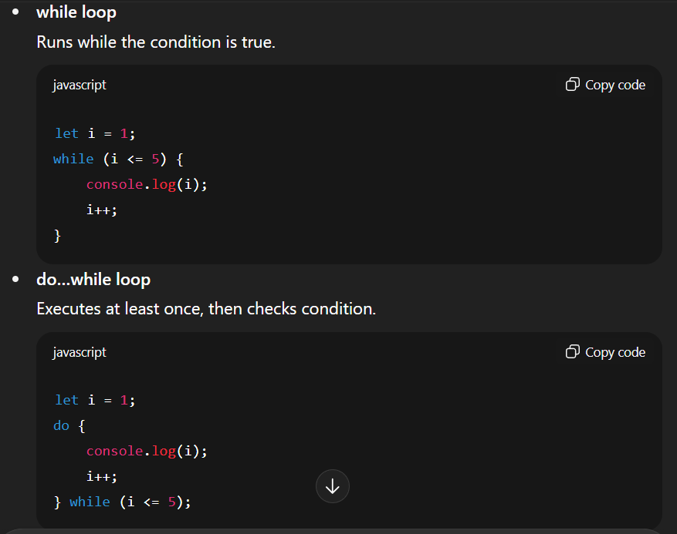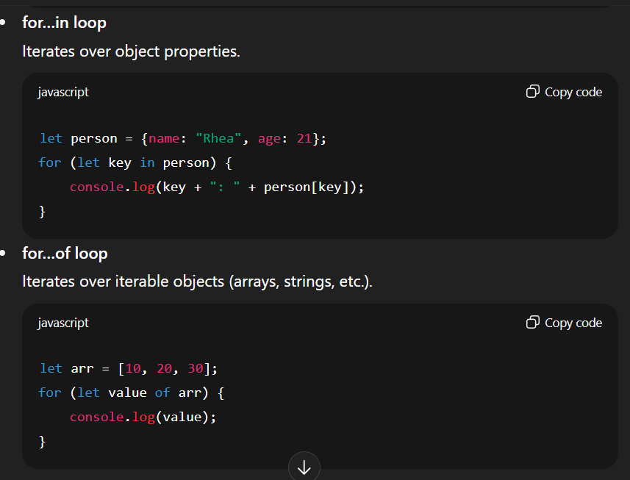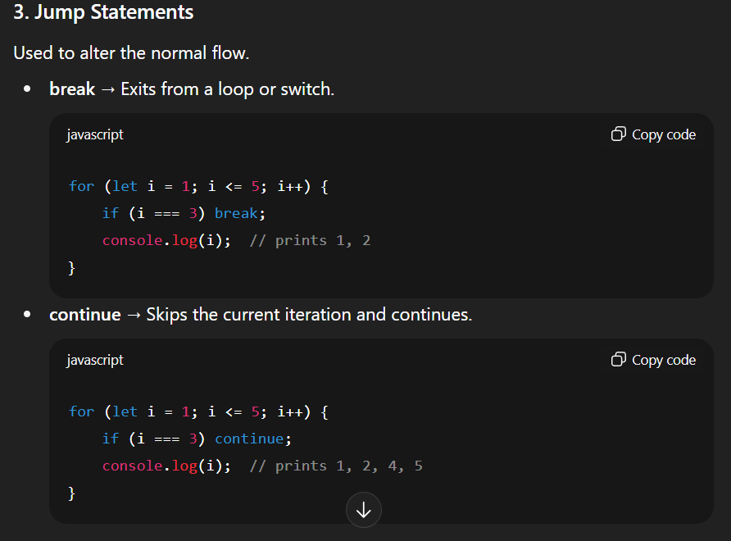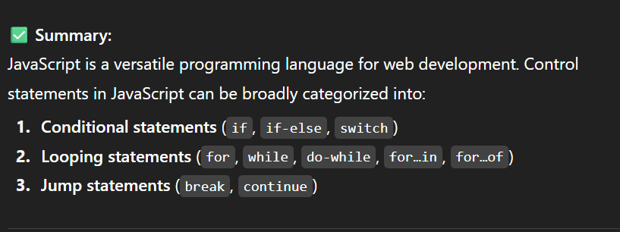

1. Explain the concept of Document Object Model with example.

**Module 3**

**3 marks**

**7marks**

**Module 4**

**3 marks**

**7marks**

**Module 5**

**3 marks**

**7marks**